Q. In our IR lectures, we’ve discussed a variety of algorithms, that in turn employ a variety of data structures. List 5 data structures, and discuss (in a single sentence) a corresponding algorithm. Stick to what we covered!

A.

1. Set: Boolean retrieval model

2. Vector: Cosine similarity, tf-idf

3. Hashing: SimHash for near-duplication

4. Array: Positional Indexing & Term Frequency Storage

5. Queue: Crawling & Search Engine Indexing

Q. How do we measure the quality of search engines?

A. Using Precision and Recall.

Precision is: the relevant items retrieved / all items retrieved.

Recall is: the relevant items retrieved / all relevant items.

Precision is how many items are relevant from all the items that have been retrieved.

Eg: How many websites are relevant from all the websites that have been crawled and displayed.

Recall is how many retrieved items are relevant from all the relevant items possible.

Eg: How many websites are relevant from all the websites that have been crawled and displayed, as compared to all the relevant websites available for it.

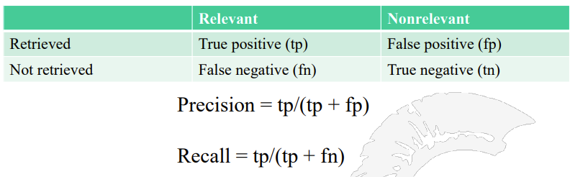

For web applications, Precision is more important than Recall.

This is because Recall is not easy to measure as in Recall, we need all relevant items for calculation.   
We don’t really know what that means. We don’t have an estimate of all the relevant values available to us.

Hence, Recall is not a great measure.

**DEMORGAN’s LAW:**

De Morgan's Laws describe how logical operations interact with negation. They are fundamental in Boolean algebra and set theory. The laws state:

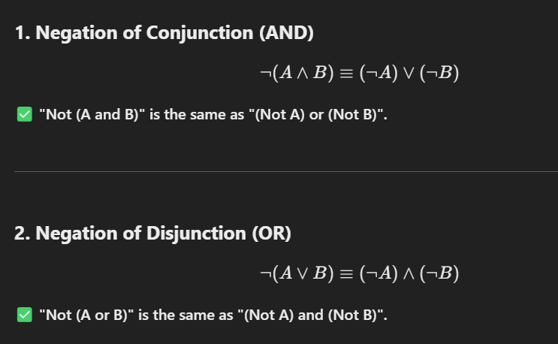

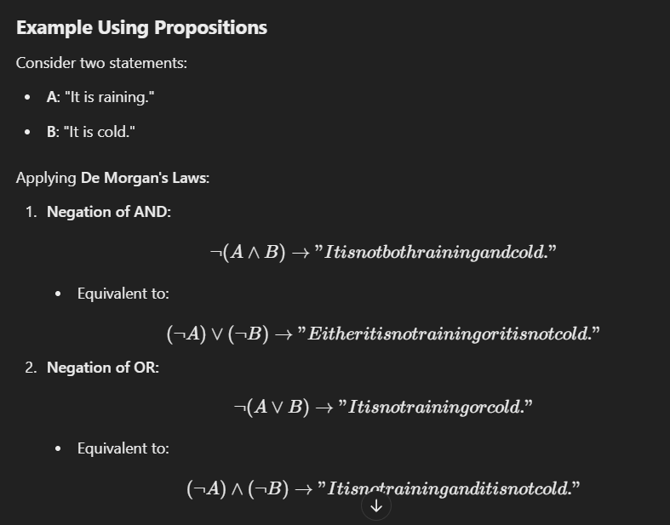

**Applications of De Morgan's Laws**

✅ **Logic Simplifications** – Used in Boolean algebra to simplify expressions.  
✅ **Circuit Design** – Helps in designing efficient logic gates.  
✅ **Programming Conditions** – Optimizes conditional statements in programming.

**F-SCORE:**

The **F-score (F1-score)** is calculated using the **harmonic mean** of precision and recall rather than the **arithmetic mean** or **geometric mean** because of the following reasons:

**1. Balancing Precision and Recall**

* **Arithmetic Mean** (P+R)/2 would treat precision and recall independently, which might overestimate their importance even if one of them is very low.
* **Harmonic Mean** (2(P*R) / (P+R)) ensures that both precision and recall contribute equally and prevents one from dominating the score.

**2. Sensitivity to Extreme Values**

* The **harmonic mean** gives more weight to the smaller of the two values.
* If either precision or recall is very low, the **F1-score also remains low**, reflecting poor performance.
* The **geometric mean** sqrt{P*R} also balances the two values but does not penalize extreme imbalances as much as the harmonic mean does.

**3. Mathematical Justification**

* In classification problems, **precision and recall have an inverse relationship**: improving one can sometimes decrease the other.
* The **harmonic mean provides a better measure of their trade-off** by emphasizing their lowest value.

**DISCOUNTED CUMULATIVE GAIN:**

In F score, we consider the relevance, but we don’t consider the position. Sometimes, we can get all the relevant values, but it might take a lot of time.

Eg: If we have to find 3 relevant values, getting them in the first 3 tries is better than in longer iteration numbers.

Hence, DCG considers position as well. **Discounted Cumulative Gain (DCG)** is a ranking evaluation metric used to measure the effectiveness of ranking results by considering both **relevance and position**.

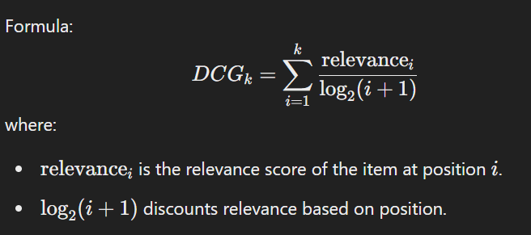

Q. Why do we use log here?

A. log() is used to:

1. To Handle Unbounded Increases:

The frequency of a term can increase indefinitely, using a log could help to moderate these effects. In other words, log(N) keeps the result more manageable/reasonable by making it grow a lot slower than N.

1. Normalize the Impact Between High and Low Frequency Terms: Log scaling helps balance the influence of high and low-frequency terms, ensuring that high-frequency terms don’t dominate while giving more weight to rarer terms, leading to a more balanced contribution of each term.

Q. How to visit a website without typing it in the browser?

A.

1. java.net.url

2. Postman API

3. curl in your cmd

Bing uses five crawlers

– Bingbot, standard crawler

– Adidxbot, used by Bing Ads

– MSNbot, remnant from MSN, but still in use

– MSNBotMedia, crawls images and video

– BingPreview, generates page snapshots

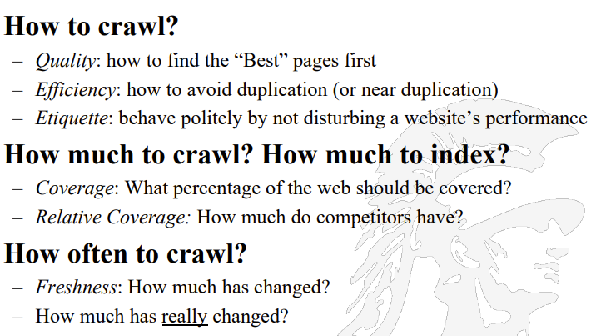

Crawl Challenges

– Handling/Avoiding malicious pages

Some pages contain spam

Some pages contain spider traps – especially dynamically generated pages

– Even non-malicious pages pose challenges

Latency/bandwidth to remote servers can vary widely

Robots.txt stipulations can prevent web pages from being visited

How can one avoid mirrored sites and duplicate pages

– Maintain politeness – don’t hit a server too often

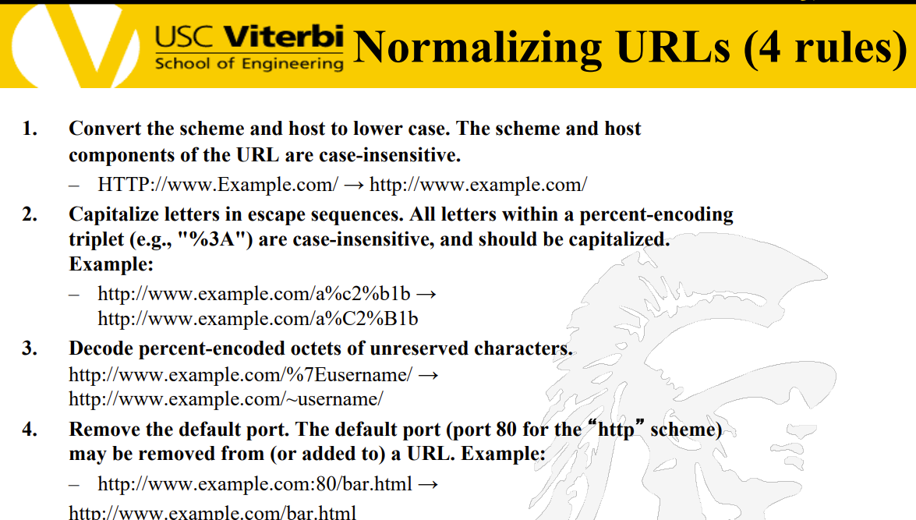

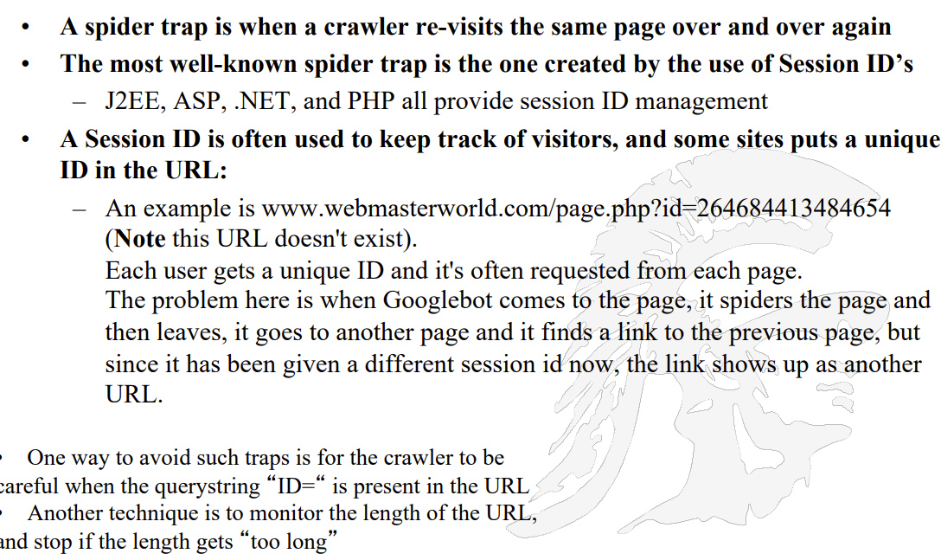

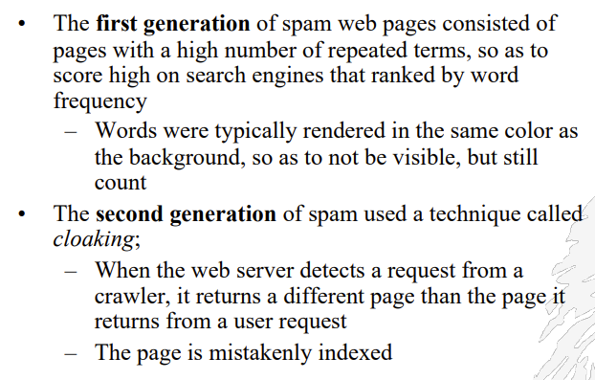

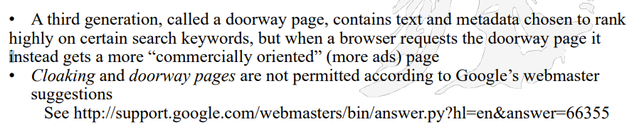

Q. How are crawlers checked for multi threading?  
A. 2PC.



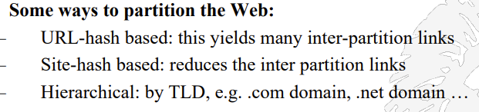

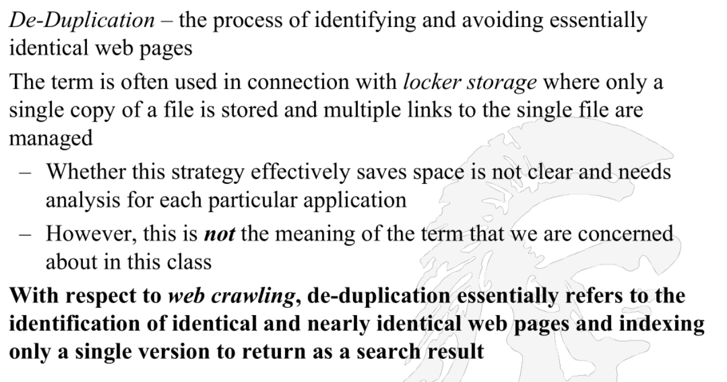

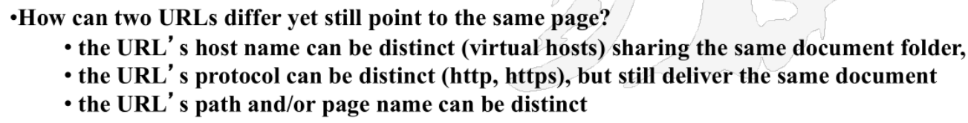

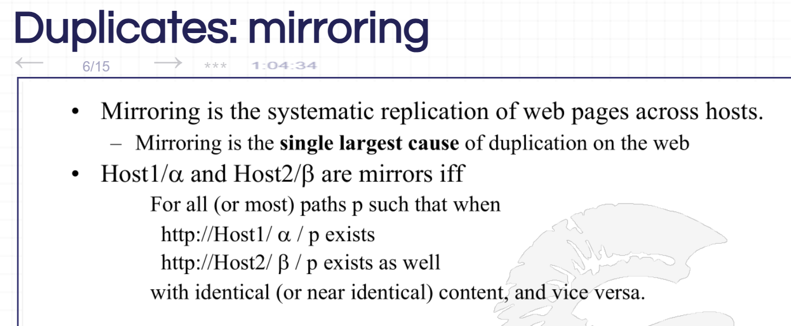

**Why is MD5 Not Reliable for Near-Duplication?**

1. **Sensitive to Small Changes (Avalanche Effect)**
   * Even a tiny change in input results in a completely different MD5 hash, making it unreliable for detecting near-duplicates.
2. **No Similarity Preservation**
   * Similar inputs do not produce similar hashes, unlike SimHash or MinHash, which are designed for near-duplicate detection.
3. **Fails with Minor Edits & Formatting Changes**
   * Small changes like extra spaces, punctuation, or compression completely alter the hash, making it ineffective for detecting slight variations.
4. **Vulnerable to Collisions**
   * MD5 is broken in security and allows different inputs to generate the same hash, further reducing reliability.
5. **Better Alternatives Exist**
   * **SimHash (for webpages), MinHash (for text), and LSH (for images & audio)** are better suited for near-duplicate detection. 🚀

**How is SimHash Different from MD5 for Near-Duplicate Detection?**

SimHash is designed for **near-duplicate detection**, whereas MD5 is a **cryptographic hash function** meant for exact fingerprinting. Here’s what SimHash does **differently**:

1. **Preserves Similarity**
   * SimHash produces **similar hashes for similar inputs**, meaning small changes in content result in **small changes in the hash**.
   * In contrast, MD5 produces **completely different hashes** even for minor modifications.
2. **Uses Weighted Features Instead of Raw Input**
   * SimHash **extracts key features** (e.g., words in text, edges in images) and assigns **weights** before computing the hash.
   * MD5, on the other hand, **treats the entire input as a raw string** without feature extraction.
3. **Hamming Distance-Based Comparison**
   * SimHash allows **bitwise similarity comparison** using **Hamming distance** (counting differing bits).
   * Two SimHashes with **few bit differences** indicate near-duplicate content.
   * MD5 doesn’t support similarity checks—it either matches 100% or is completely different.
4. **Efficient for Large-Scale Duplicate Detection**
   * SimHash enables fast **approximate searches** in large datasets using **bitwise comparisons**.
   * MD5 requires a **full database scan** since small differences mean completely different hashes.

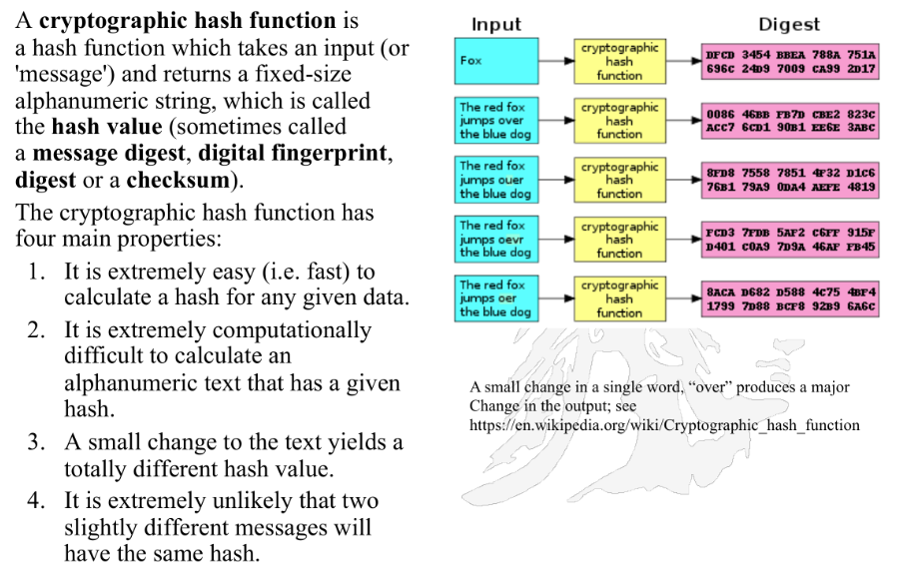

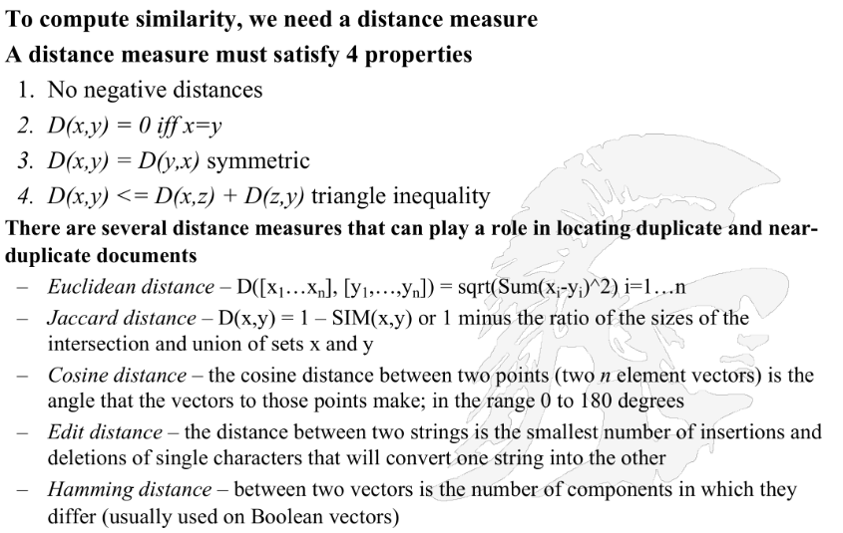

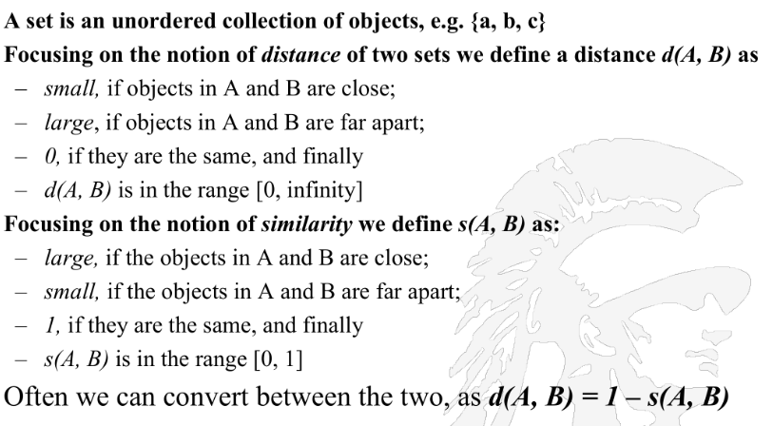

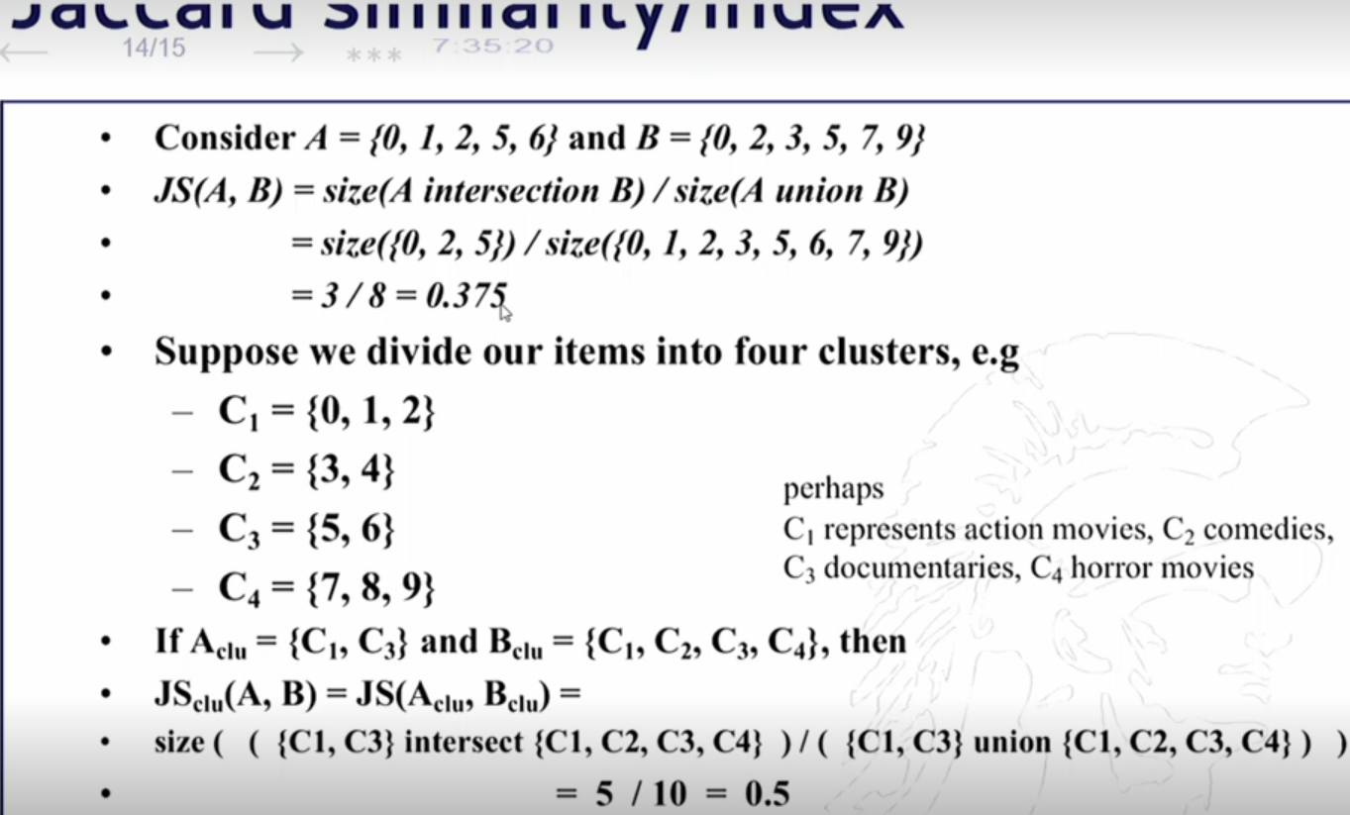

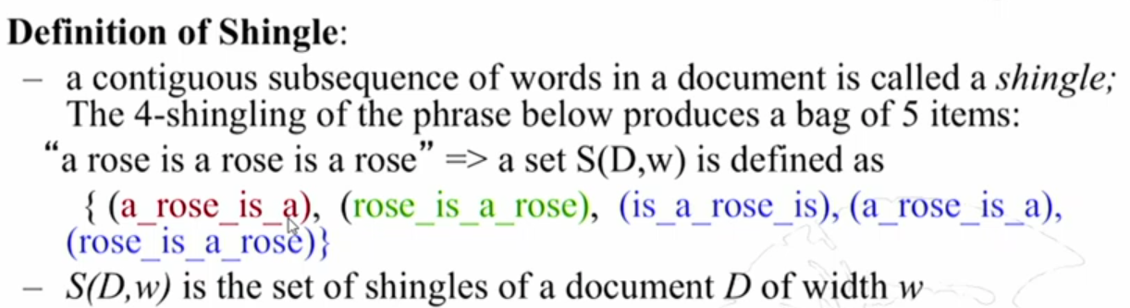

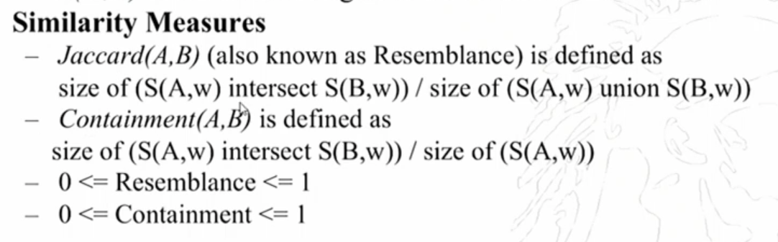

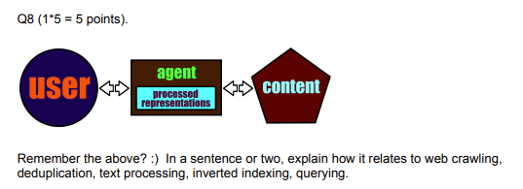

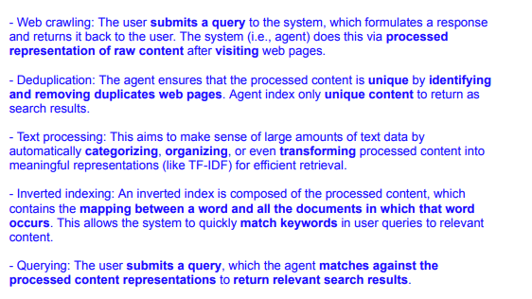

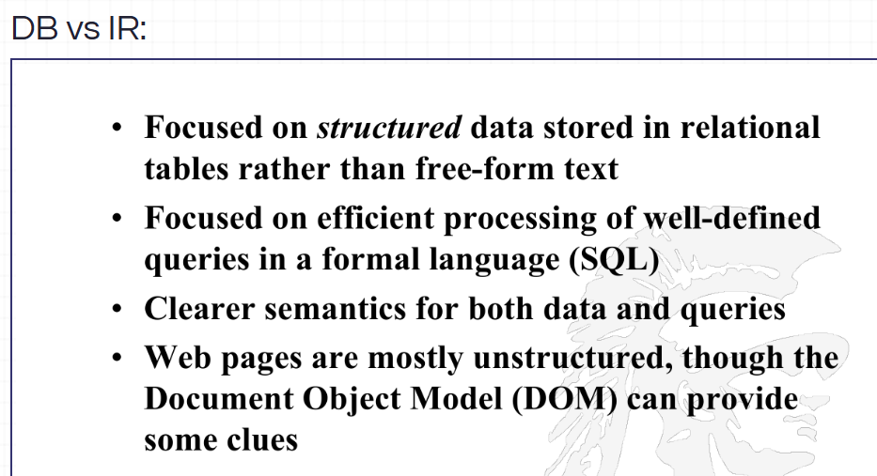

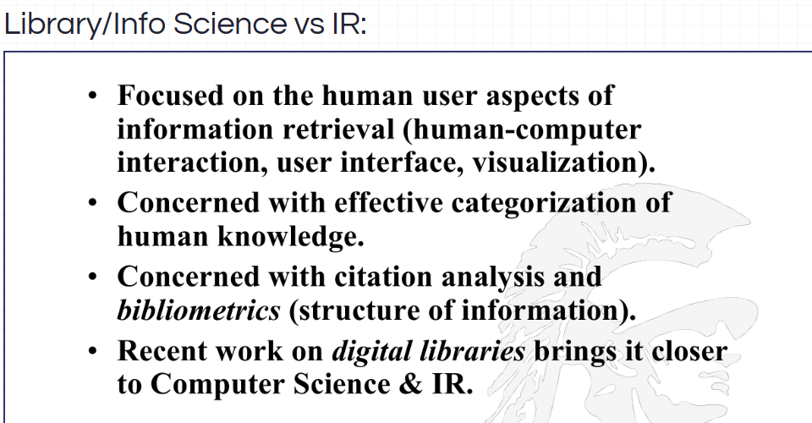

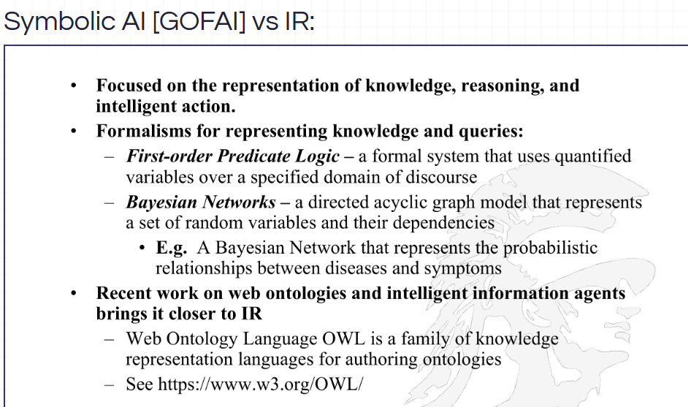

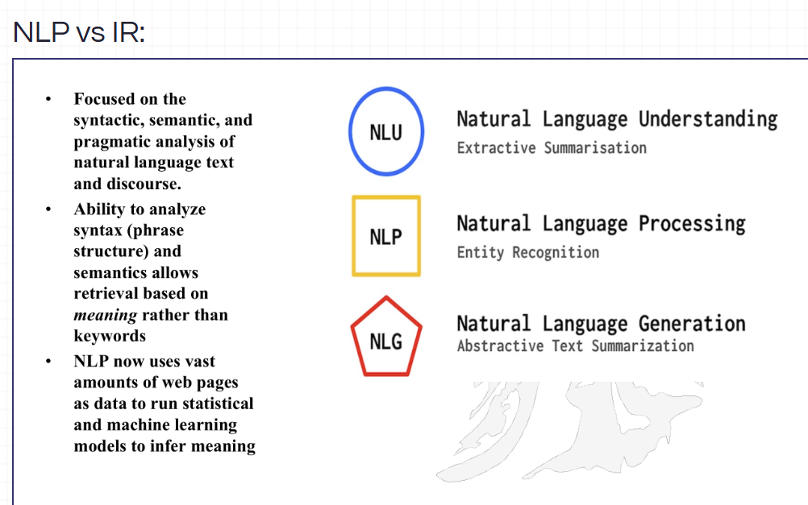

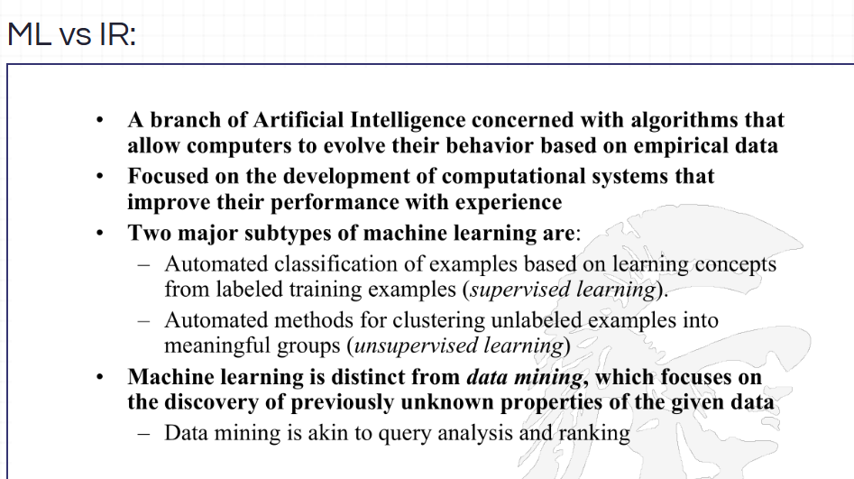

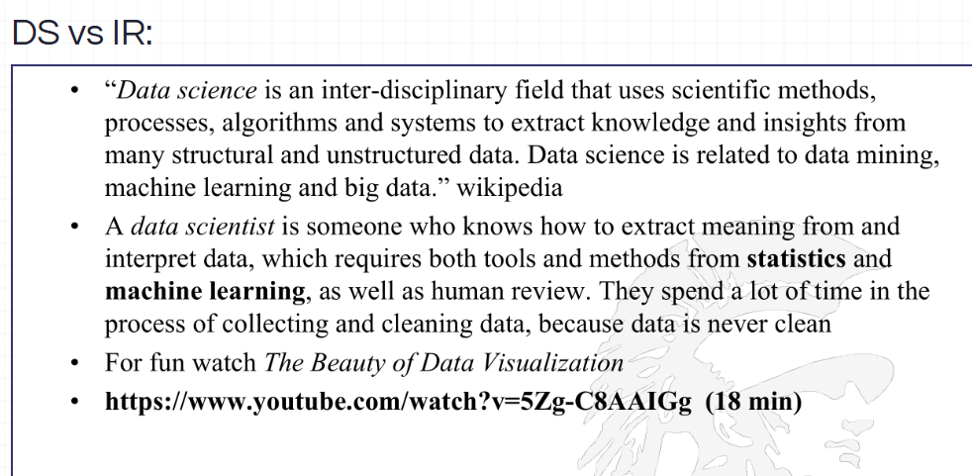

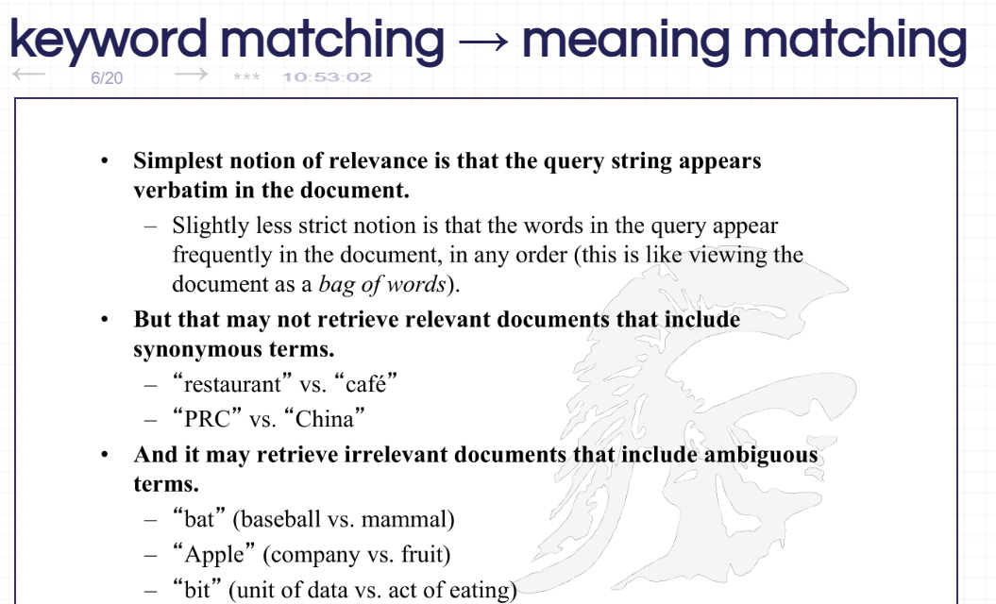

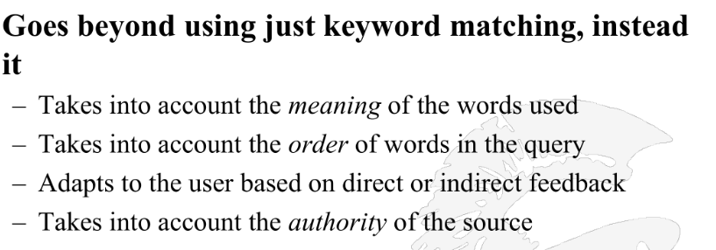

Inverted Index in Information Retrieval (IR):

An **Inverted Index** is a fundamental data structure used in **search engines and information retrieval (IR) systems** to enable fast and efficient searches across large text datasets. Instead of storing full documents and scanning them for queries, an inverted index maps each unique term to a list of documents where the term appears. This mapping significantly speeds up search operations by allowing direct lookups instead of costly full-text scans.

The **main reason for using an inverted index** is its ability to **quickly retrieve relevant documents** while optimizing storage. By storing term-to-document mappings rather than entire documents, it reduces redundancy and enables efficient searches, even for large-scale datasets. Additionally, inverted indexes support advanced search features such as **Boolean queries, phrase searches, and ranking algorithms like TF-IDF and BM25**, which improve result accuracy.

Another key advantage of an inverted index is its ability to handle **scalability and real-time search performance**. Since search engines need to process millions of queries per second, using an inverted index allows for **fast response times** while efficiently managing massive amounts of data. This makes it an **essential component in modern search engines like Google, Elasticsearch, and Lucene**, where quick and relevant information retrieval is critical.

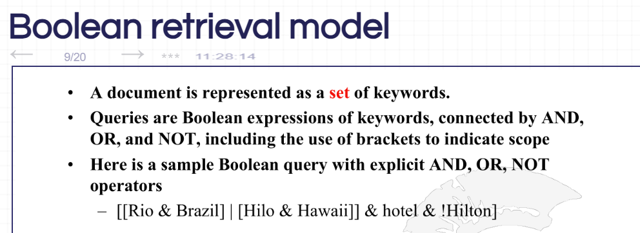

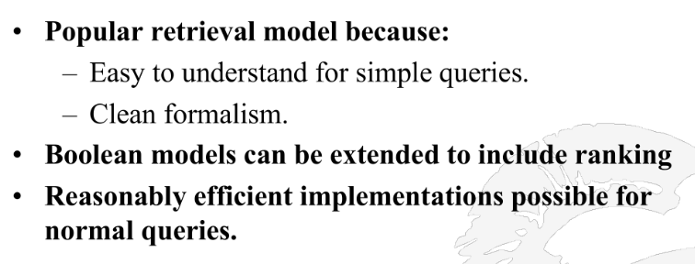

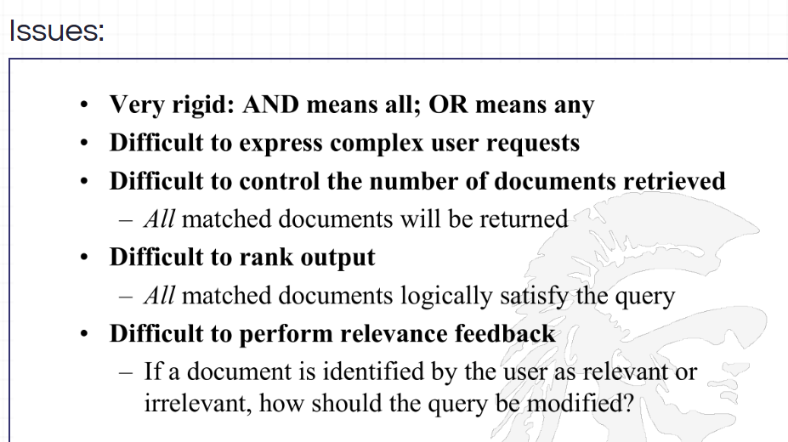

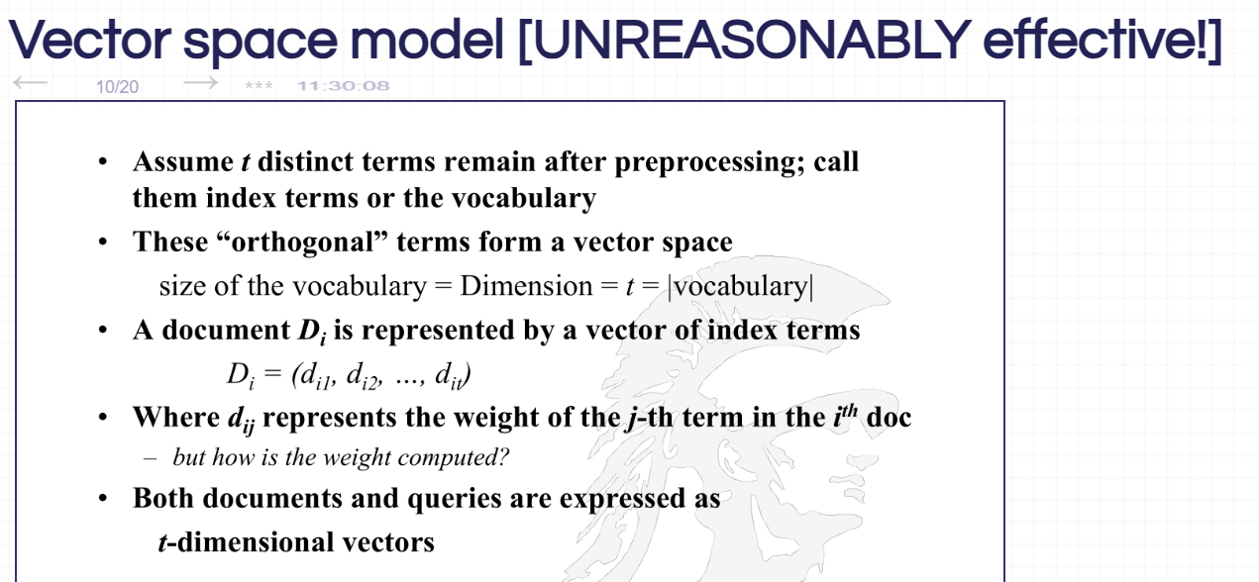

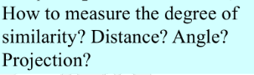

Ans:

1. dot product of vectors,
2. Distance Similarity: - Euclidean Distance
3. Angle similarity: - Cosine similarity
4. Projection: - You can project all vectors on one axis. Compare the scales

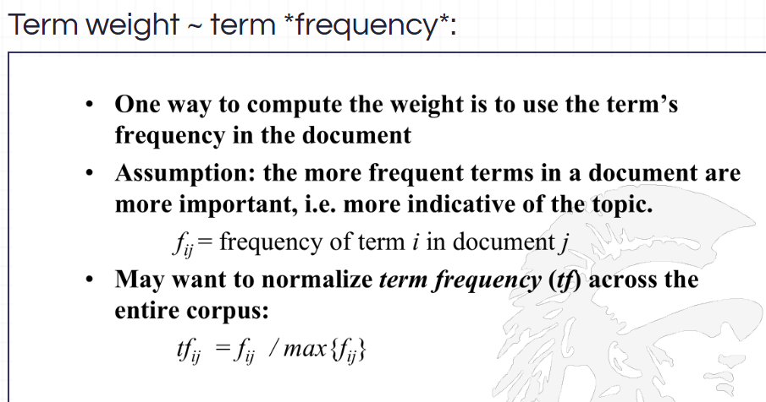

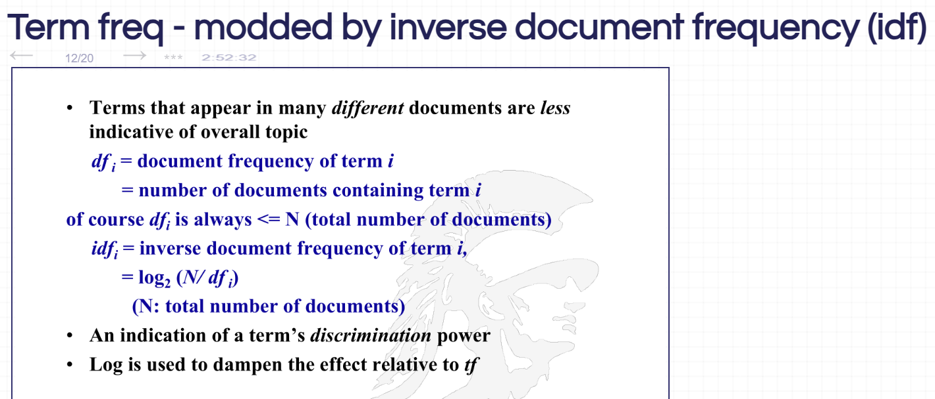

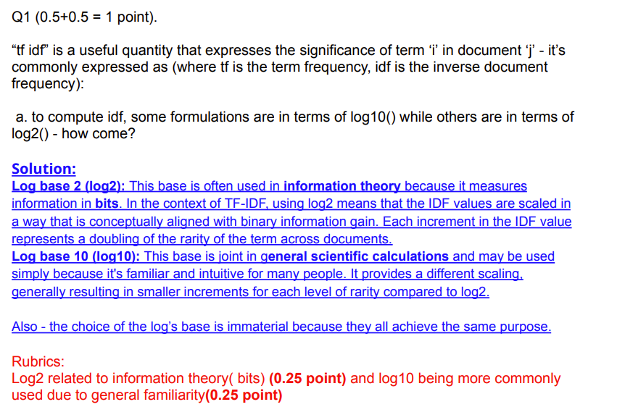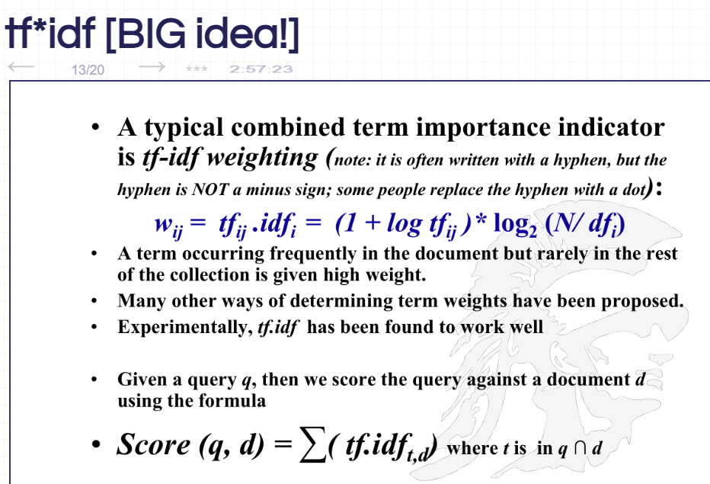

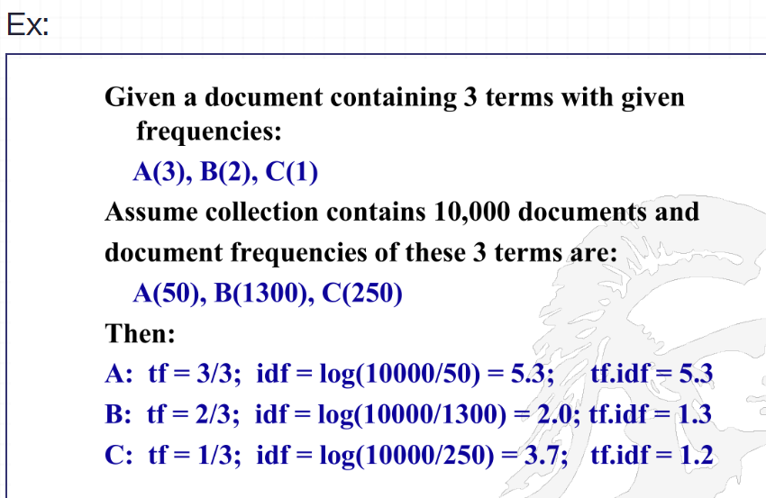

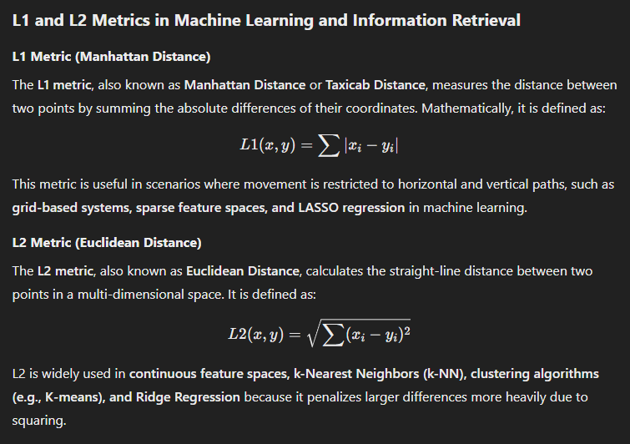

In **Information Retrieval (IR)**, these metrics help in **document similarity, ranking, and clustering**, with **L1 being better for sparse text representations** and **L2 for dense embeddings** like word vectors.



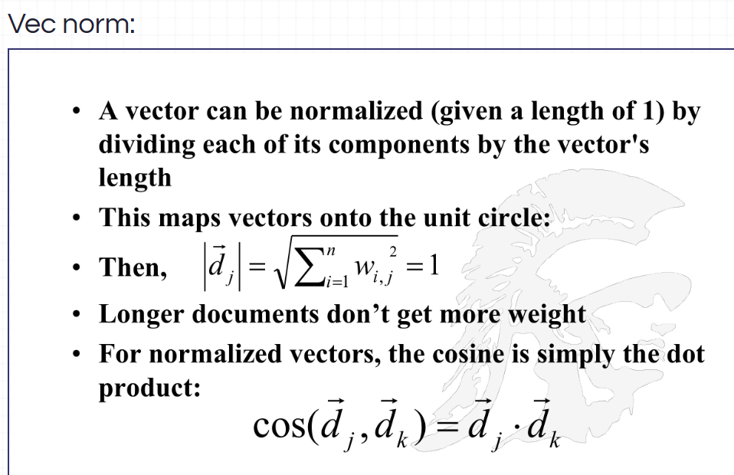

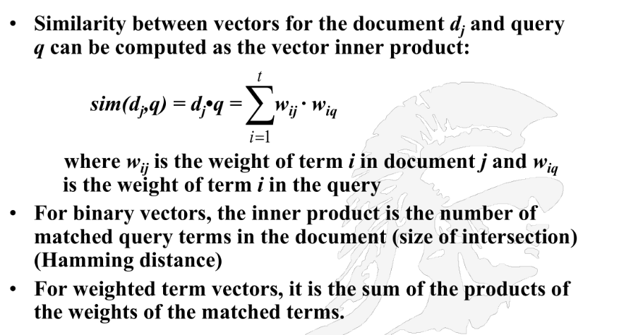

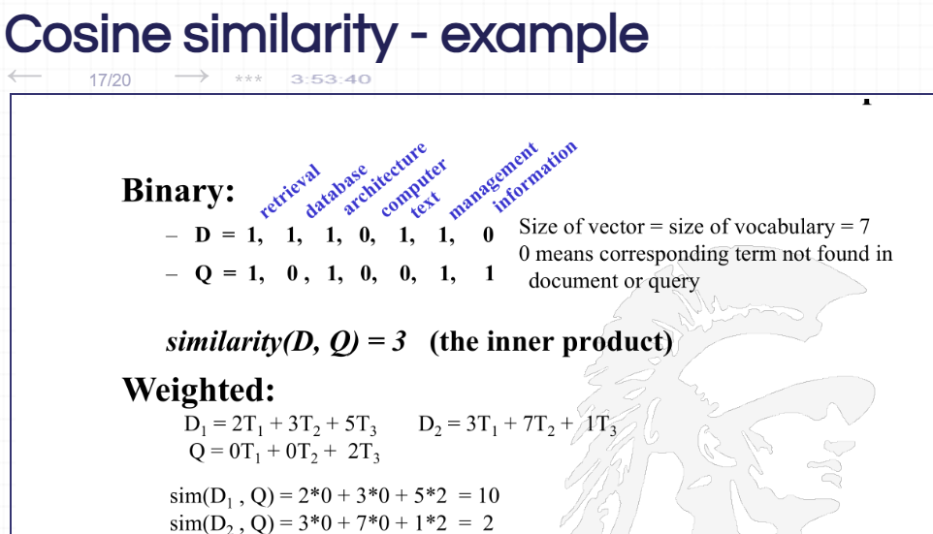

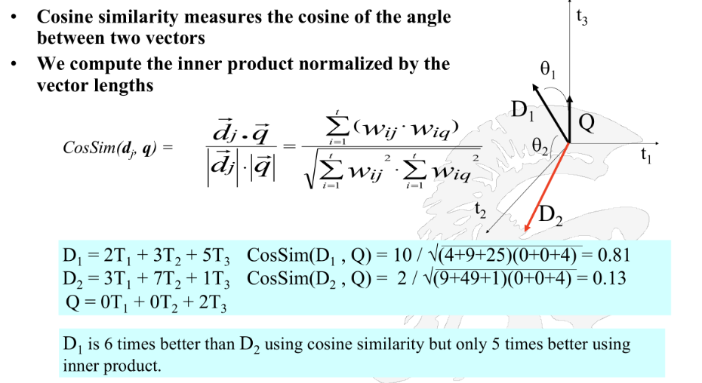

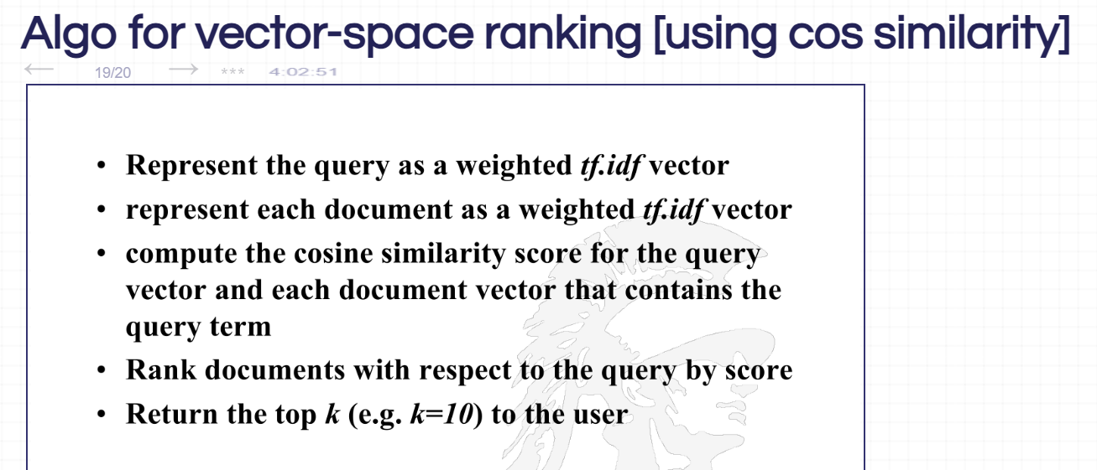

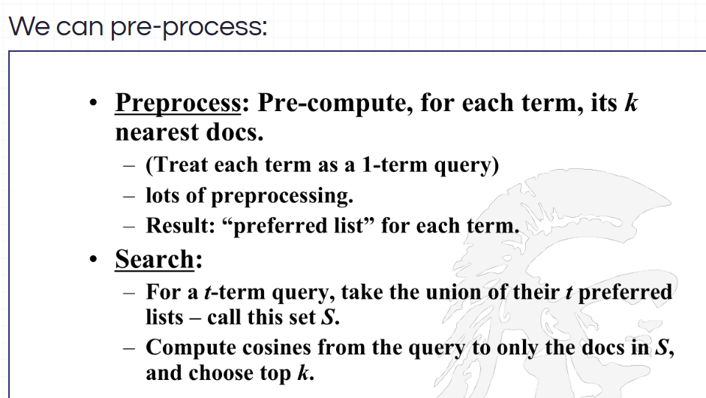

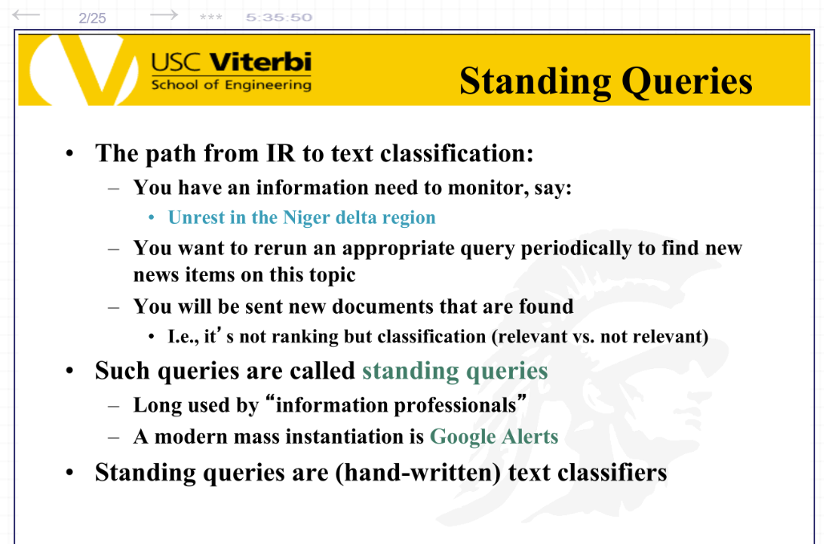

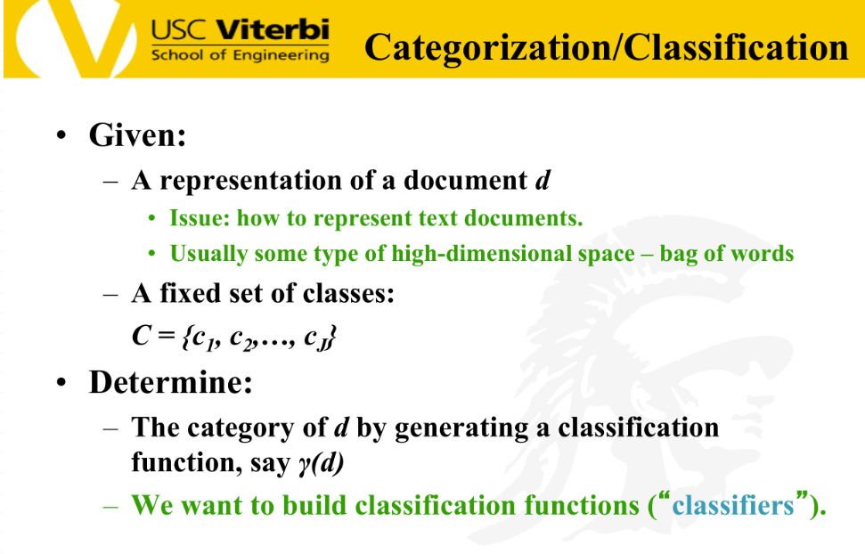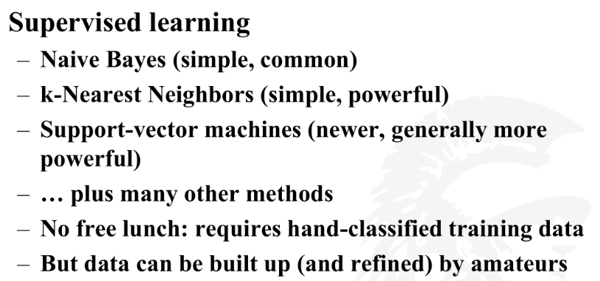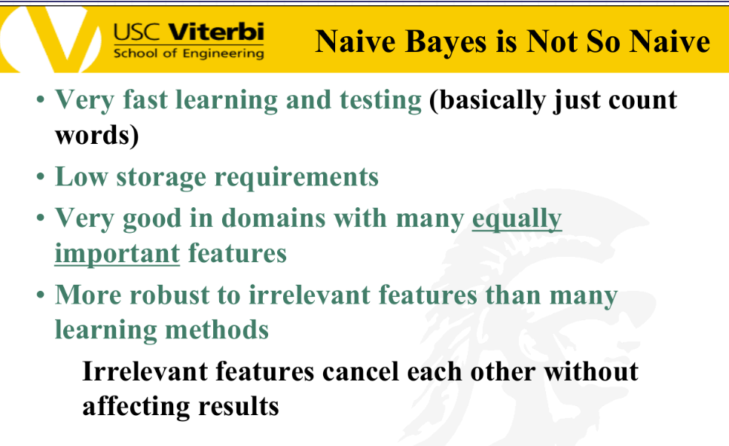

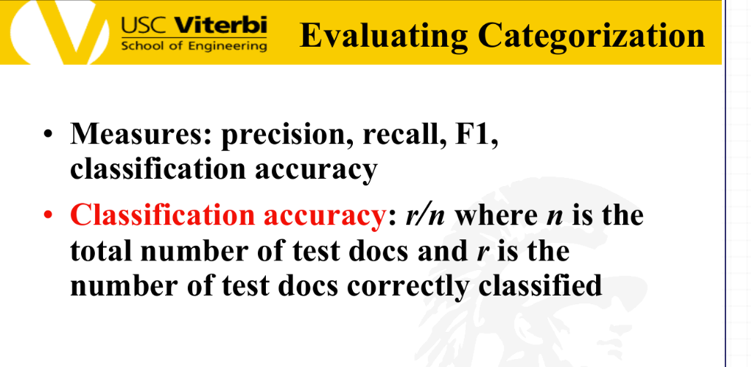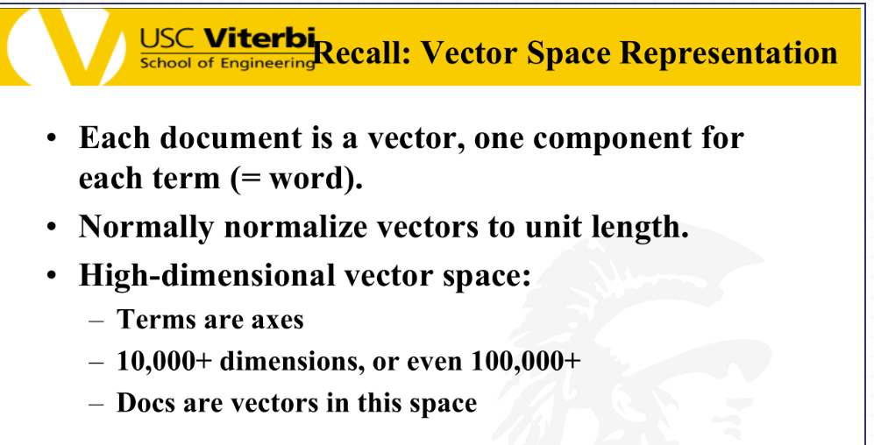

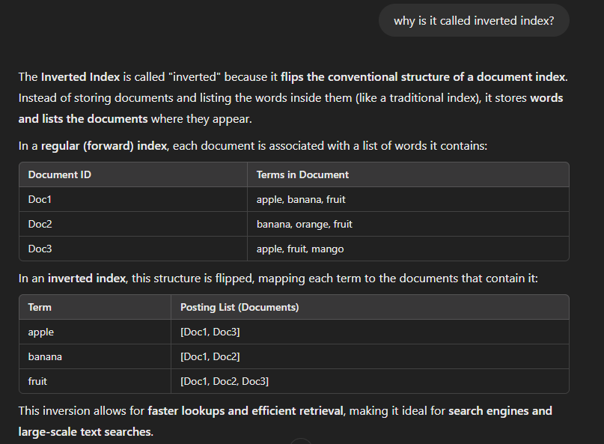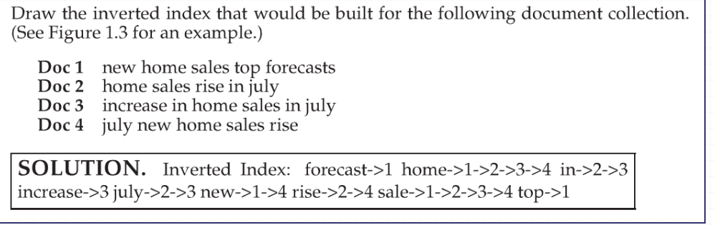



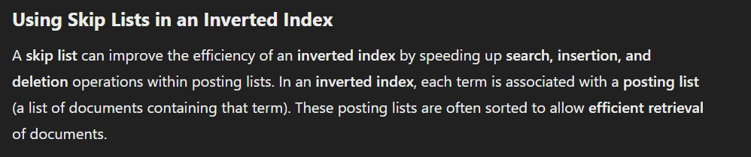

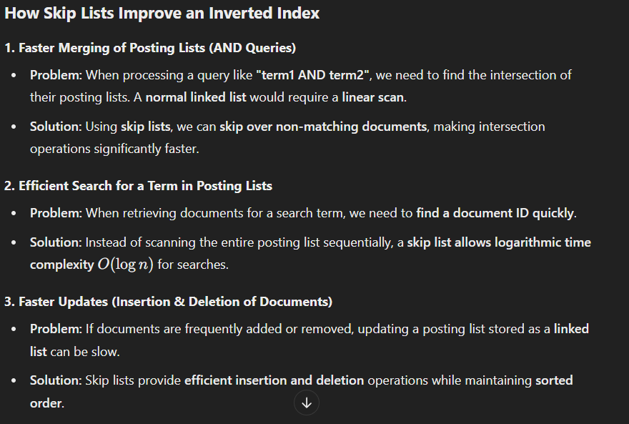

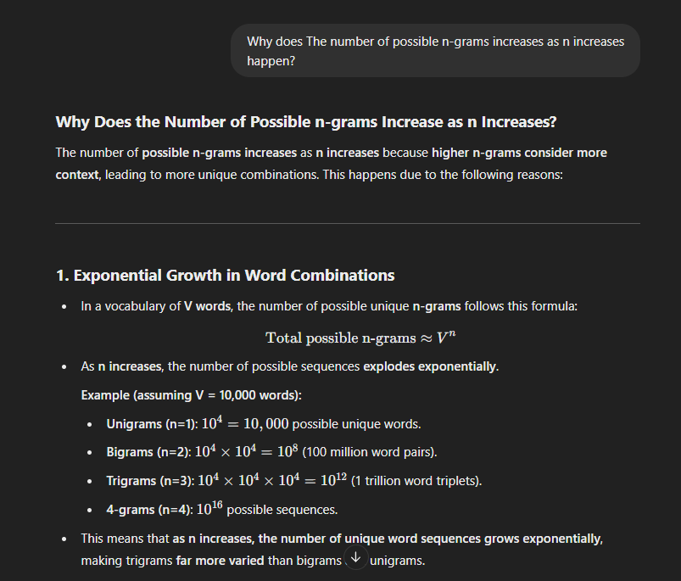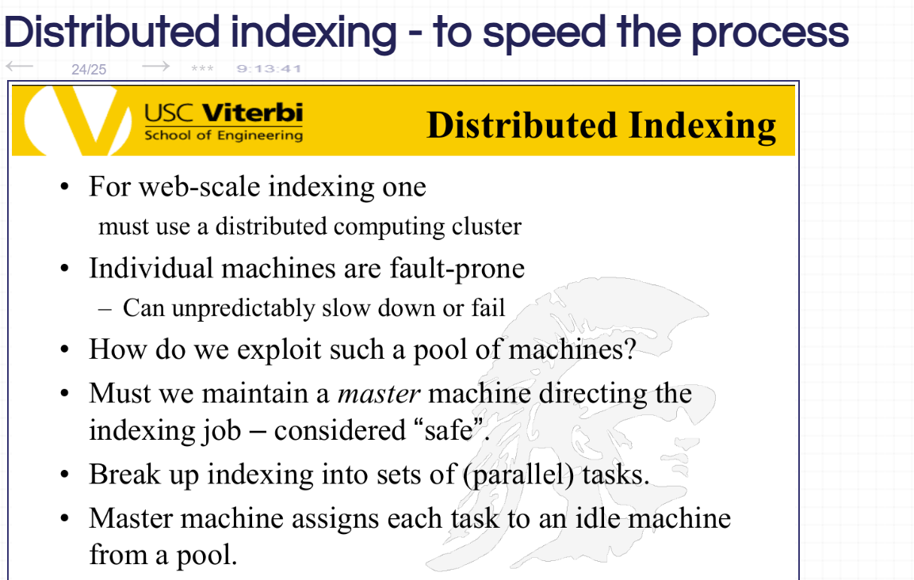

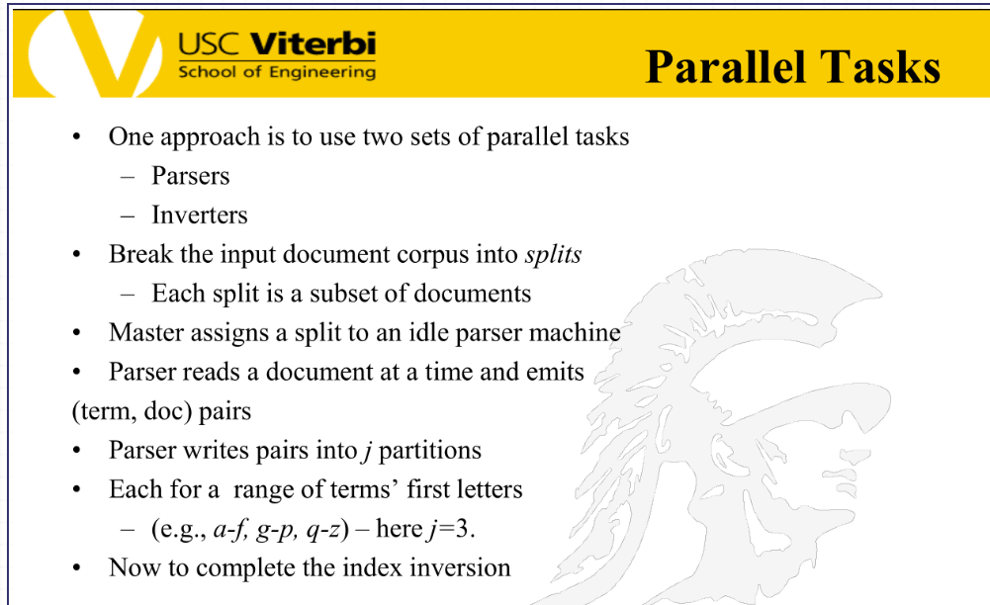

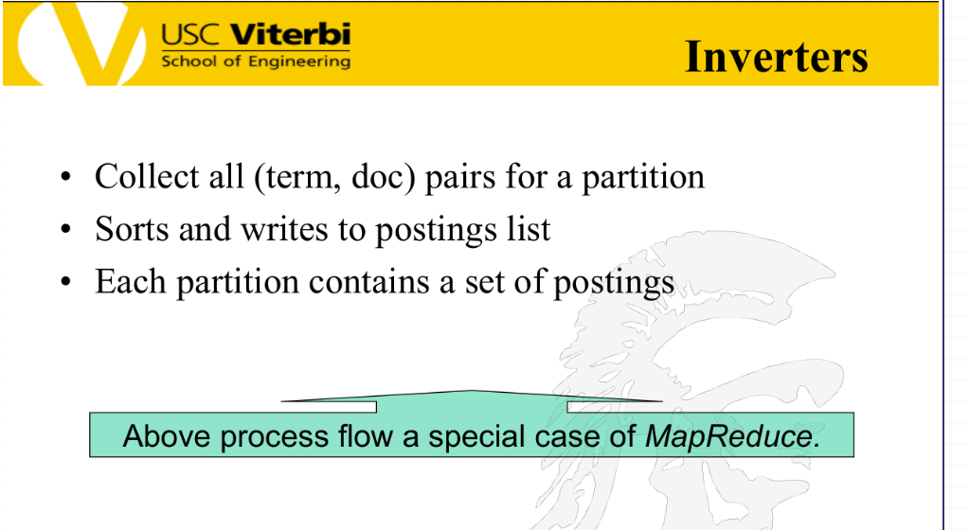

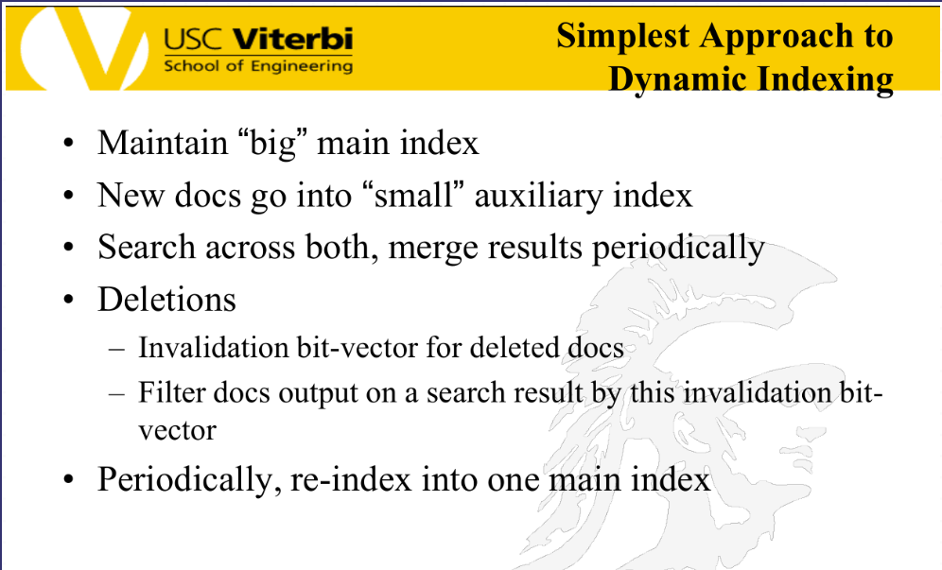

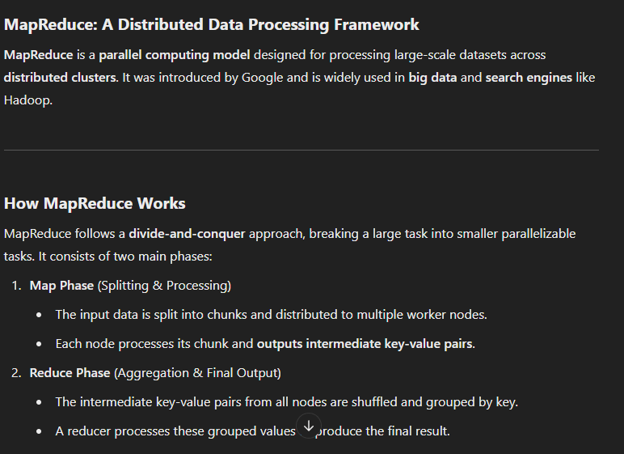

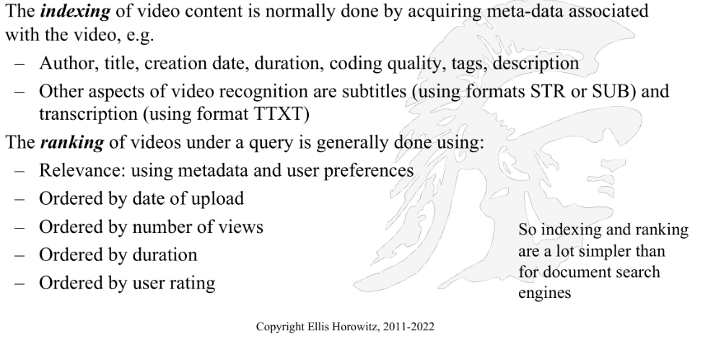

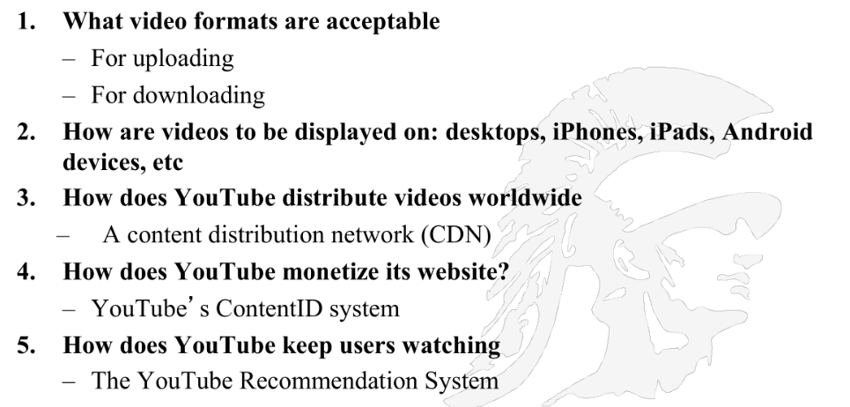

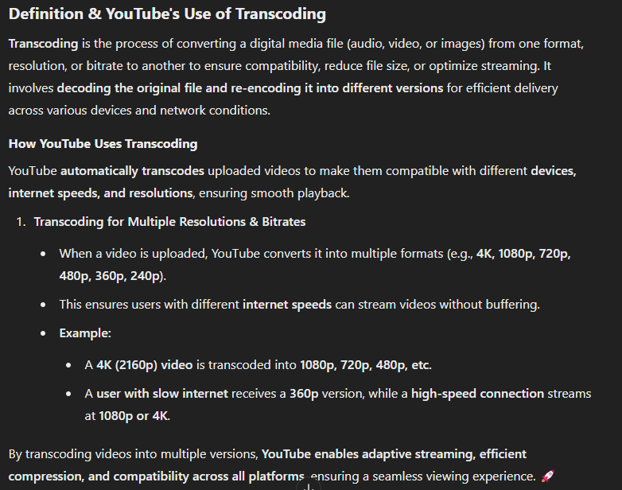

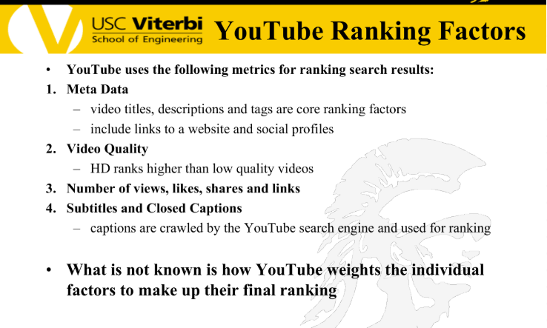

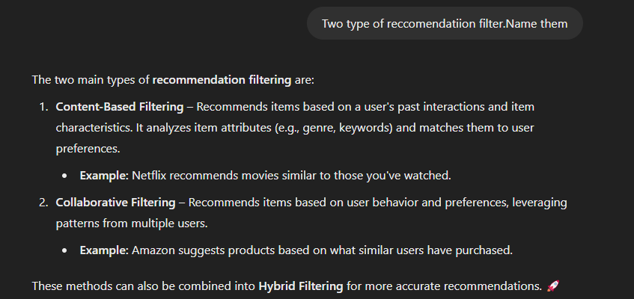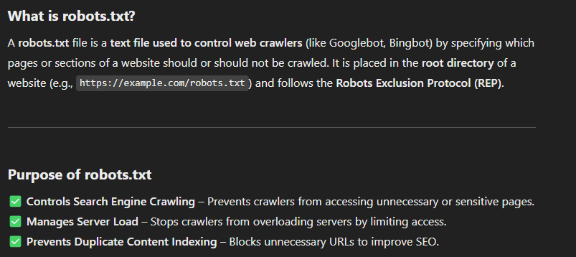

Right Now, YT asks the creators to feed in metadata about their videos and build search engines from that. In the future, AI will extract that information from the video itself.



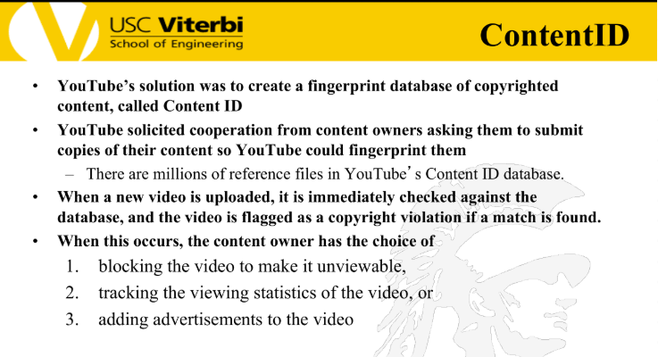

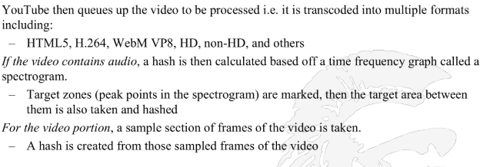

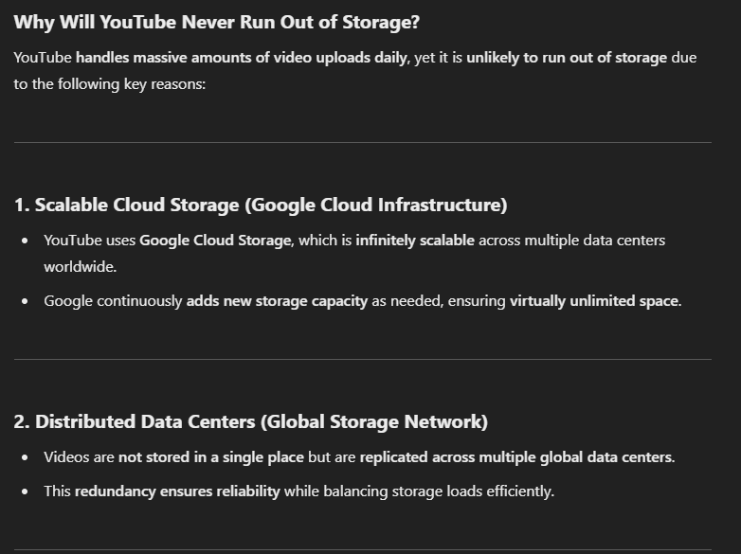

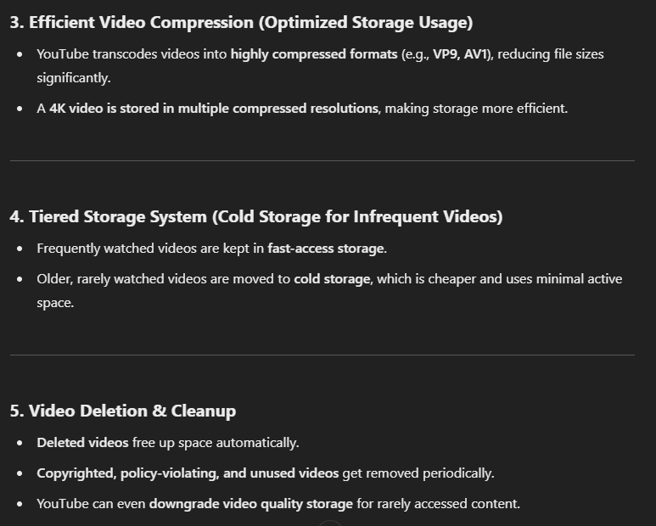

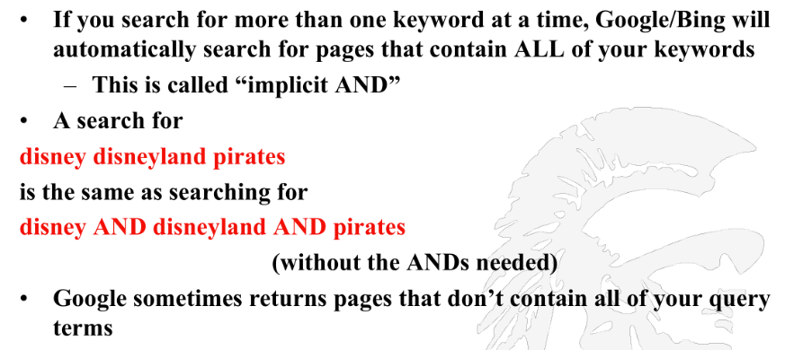

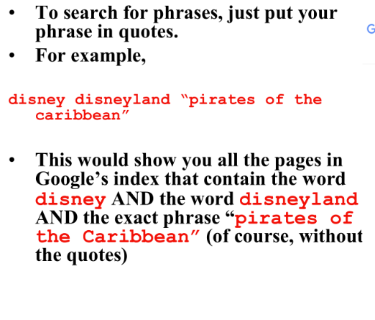

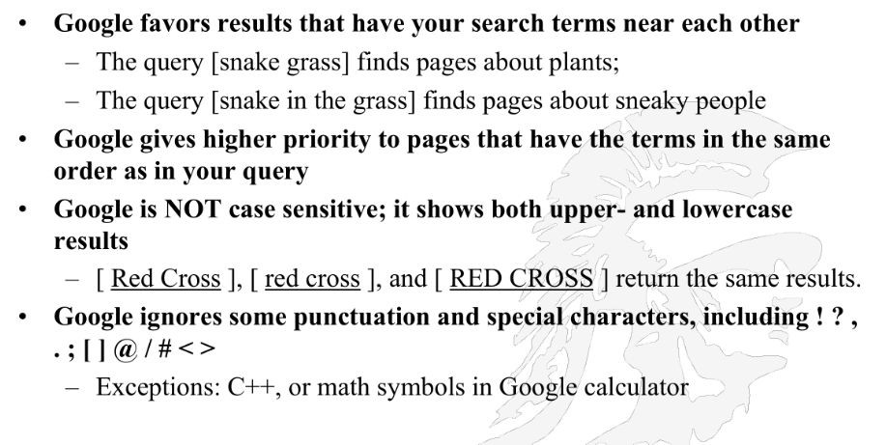

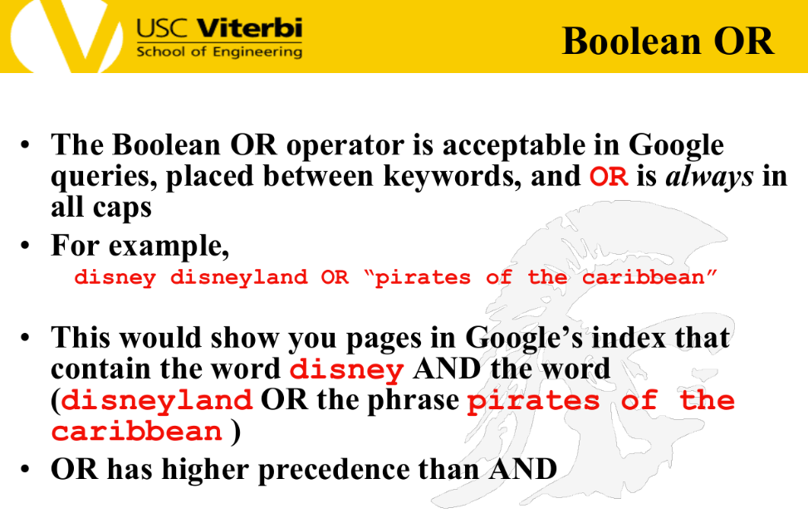

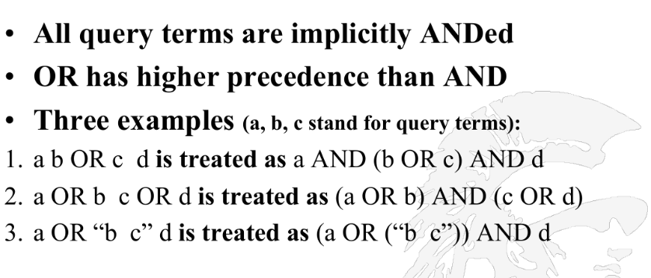

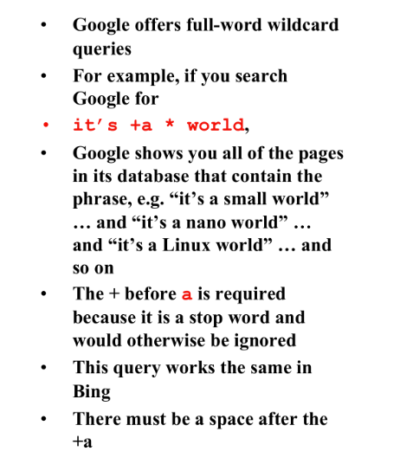

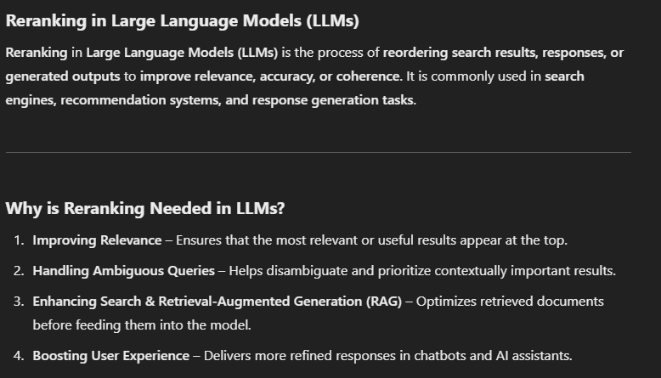

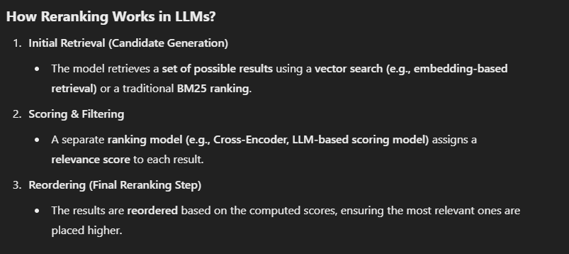

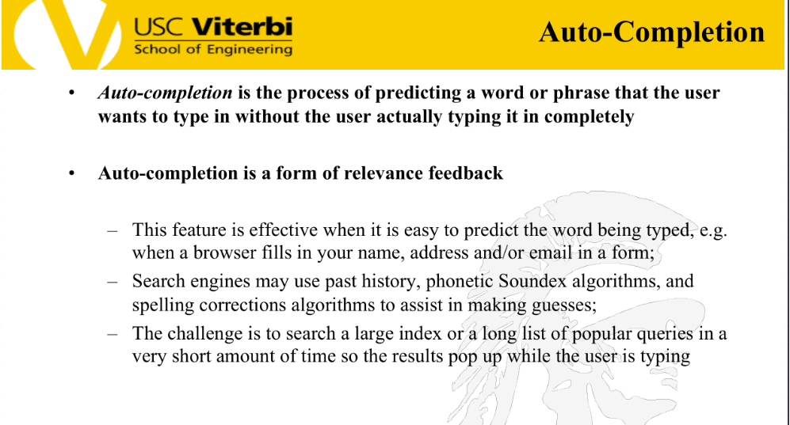

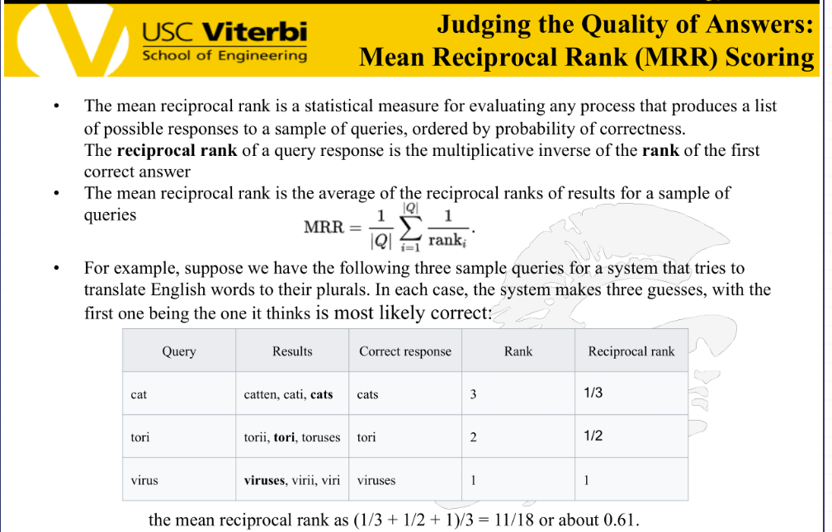

Highest value is 1, lowest is 1/n.

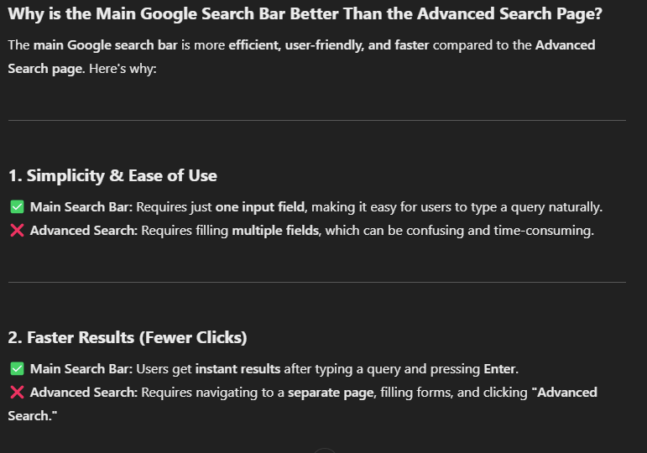



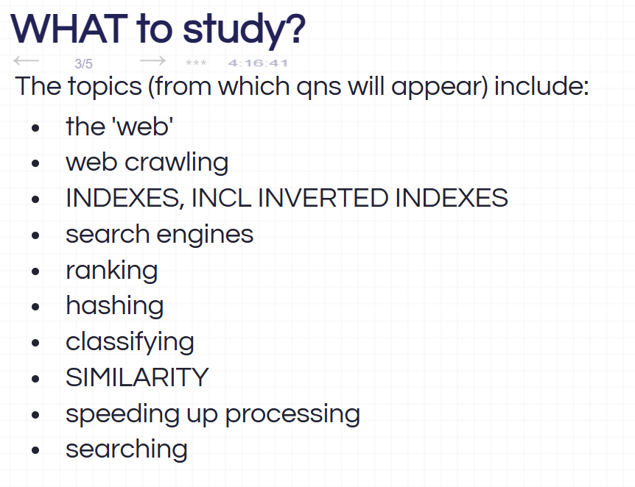

We have keyword search, what are other types of searches?

